Erasmus program 2020. 02. 29. – 03. 07.
Portugália
Papp Roland Levente 5. a

Day 1 (29 February Saturday)

The great day has finally come! The members of the group have met at the school at 10:00 on Saturday. There were six people in the group. We travelled to Budapest Airport in a minibus. We had to arrive at the airport two hours before departure of the plane.

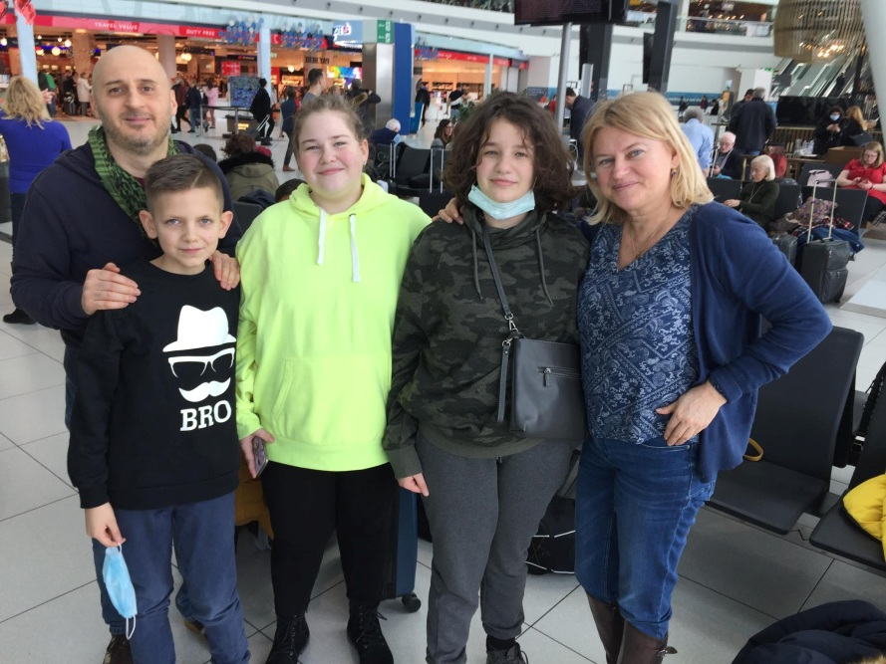

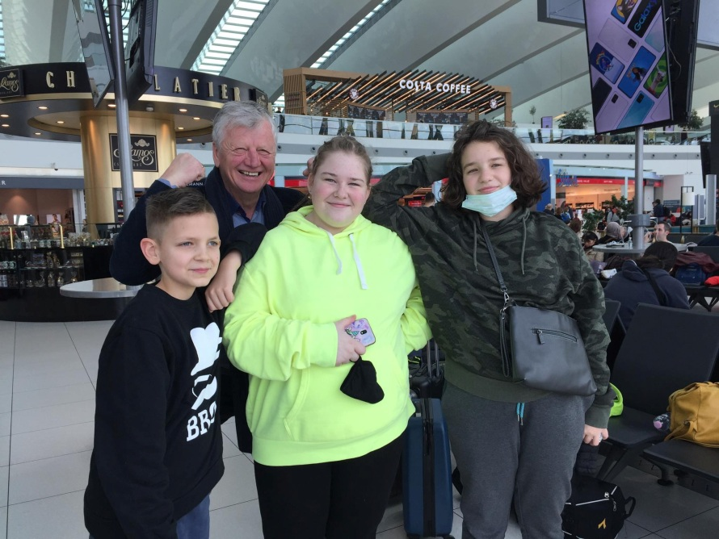
At the airport

The airplane took off to Porto at half past four in the afternoon. During taking off it was a bit scary but then I got used to it and the view through the window was magnificent. Due to the different time zones We arrived late in Vila Verde. I spent the first night at Joa’s house.

Day 2 (01 March Sunday)

The first night at a foreign place was quite strange but the host family was very helpful. After getting up we went to a see a football match in Vila Verde, where Joa played and after that we visited their grandparents and had lunch there. the whole family was there.. There was plenty of food, full of Portugese specialities.

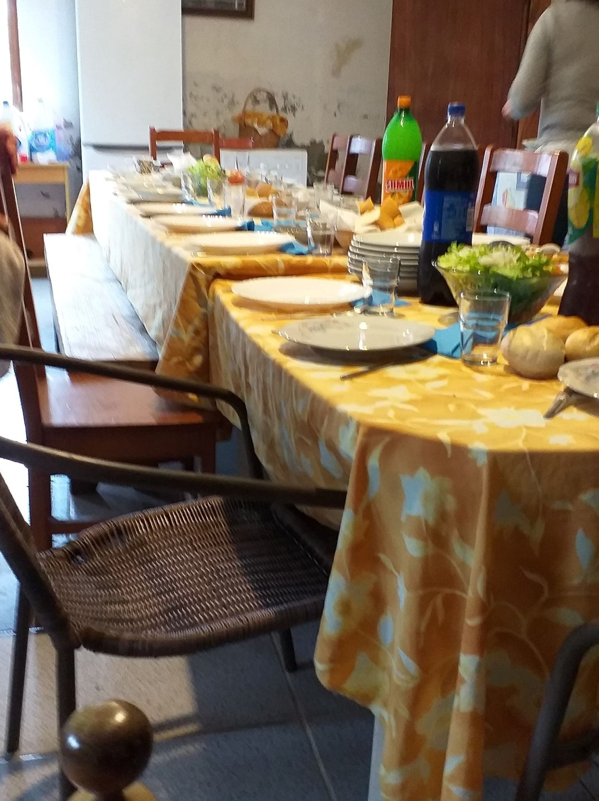
Family lunch

After lunch we went to the beach of the Atlantic. It was wonderful. We collected small stones and walked on the beach.
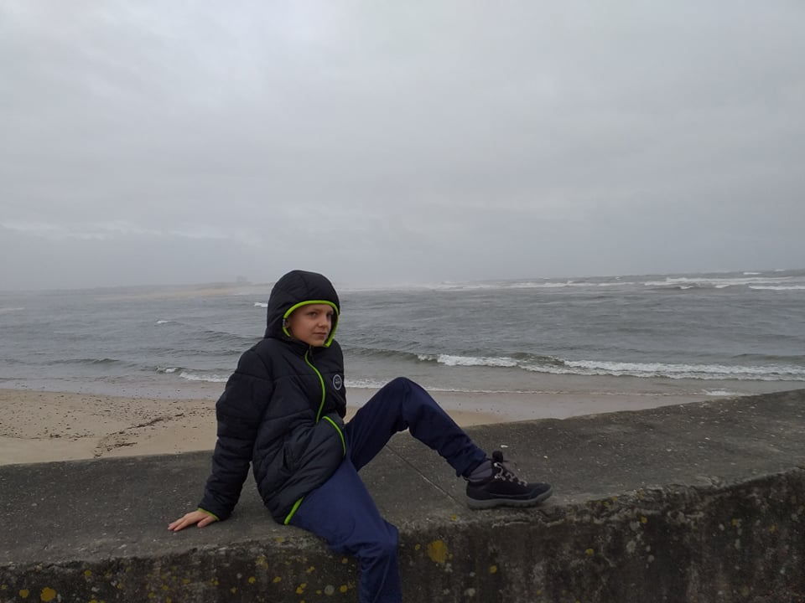

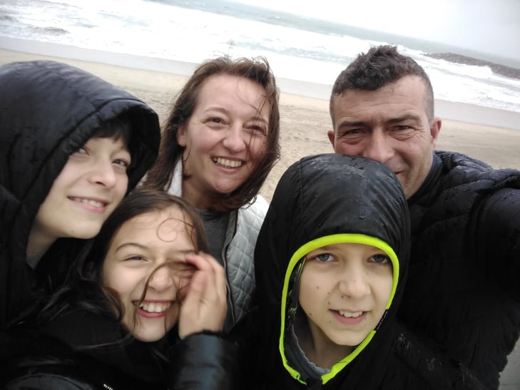
At the beach
At the end of the day we went to a confectionary in Braga.

Day 2 (02 March Monday)

The school has started! In Portugal the school starts later than in Hungary. It starts at nine o’clock and the pupils have to arrive at school at twenty-five past eight. We were shown around in school and then we went to see the school in Braga, where we saw a welcoming show for the guests.
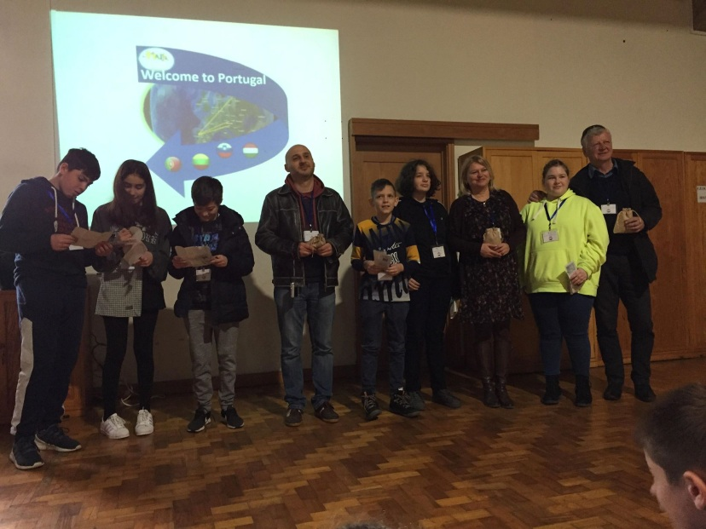
At the welcoming show

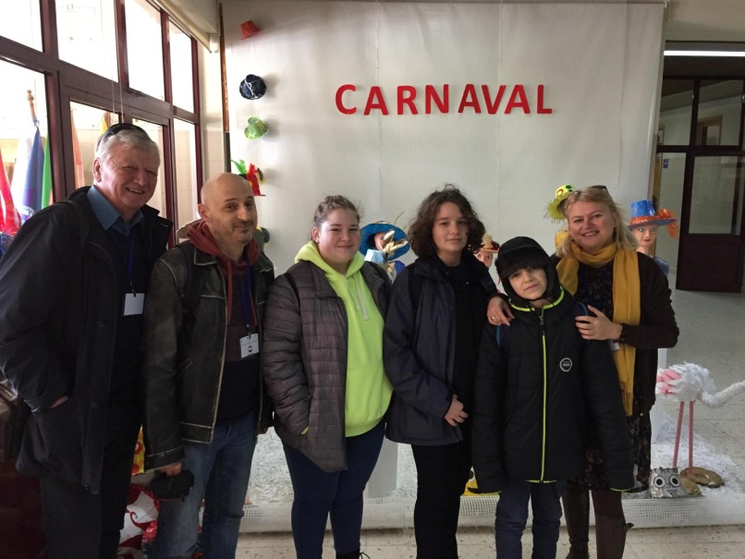
At the school in Vila Verde

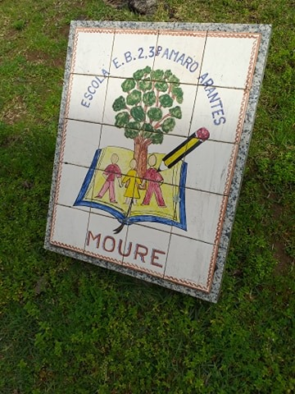
The logo of the school in Vila Verde

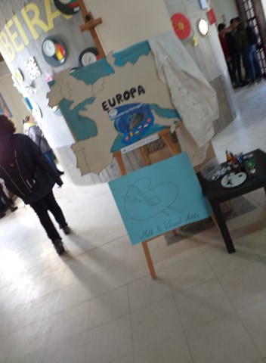
The school in Braga
We did origami in Braga.

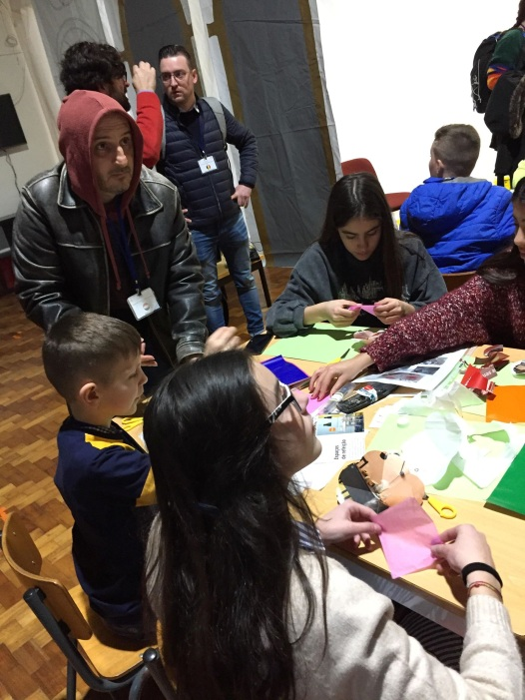
Origami

We went to the House of Science, where we saw a show about robotics technology and a short 3D film about Vila Verde.
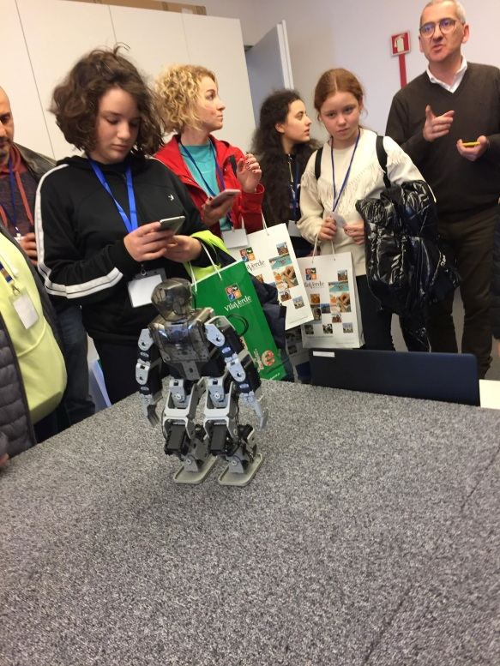
A robot show
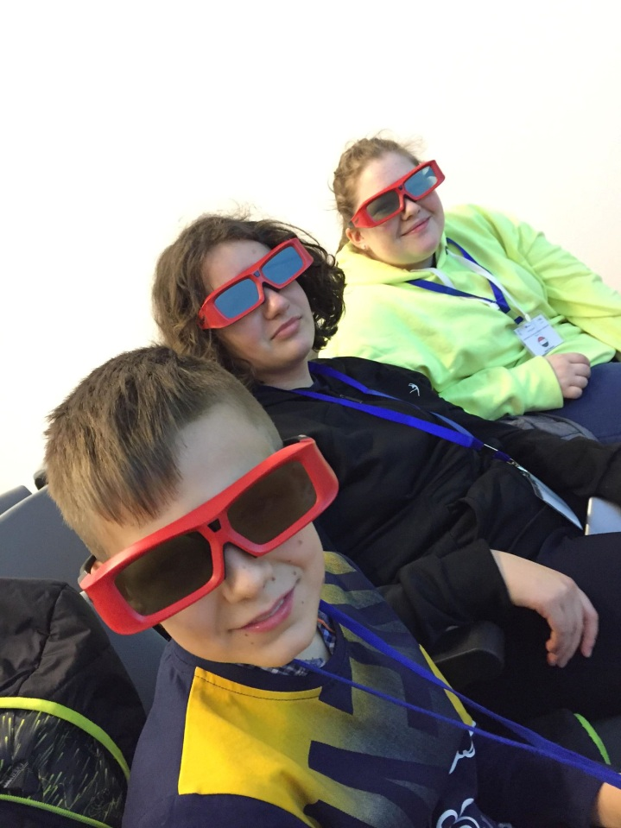
A 3D video

We went to Town Hall, where we saw a wlcoming show and got lots of presents.
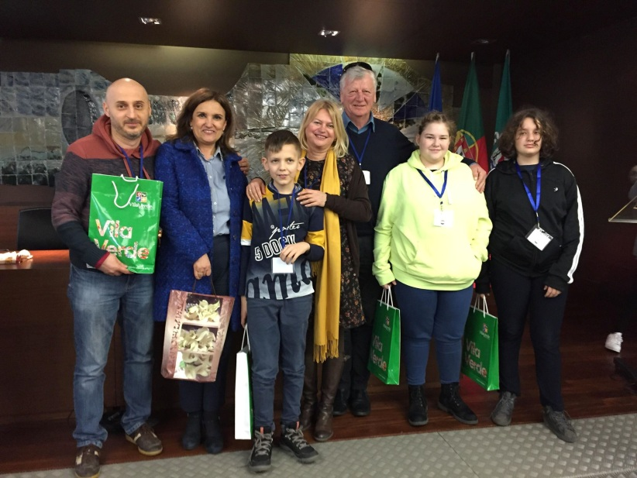
At the town hall

In Portugal school finishes at ten past five. After the school programmes we were with the host families.

Day 3 (03 March Tuesday)
The first programme was a visit to a museum in Braga.

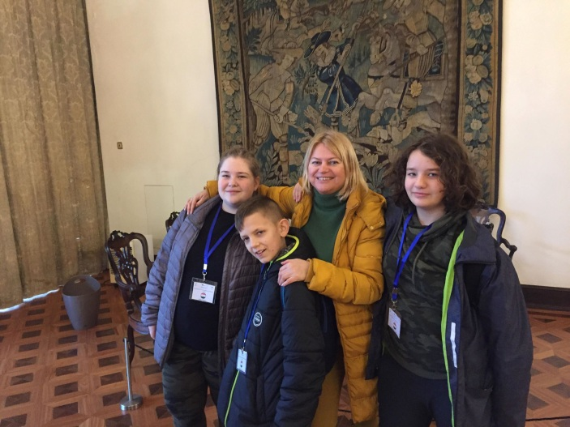

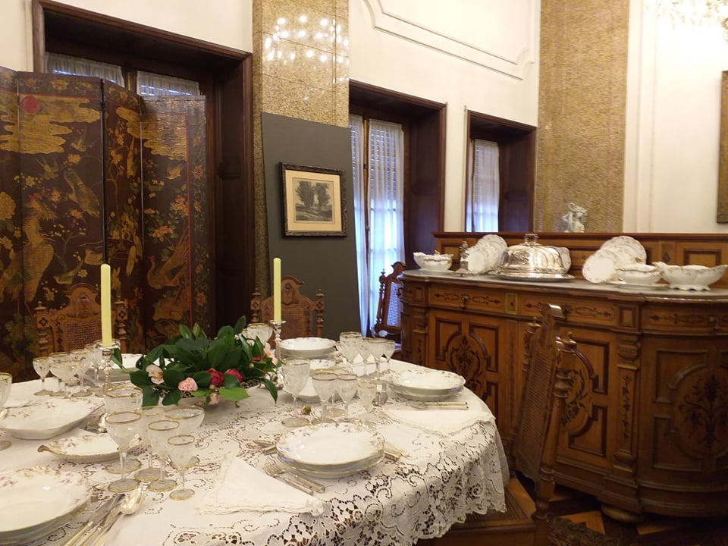

After visiting the museum we went up to a mountain with an eleveator, where there was a garden but the weather was very foggy. There was church in the garden too.

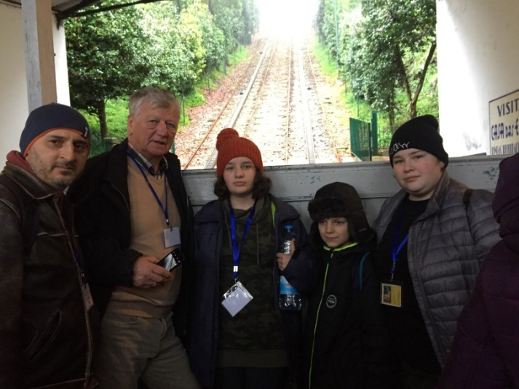
In the elevator

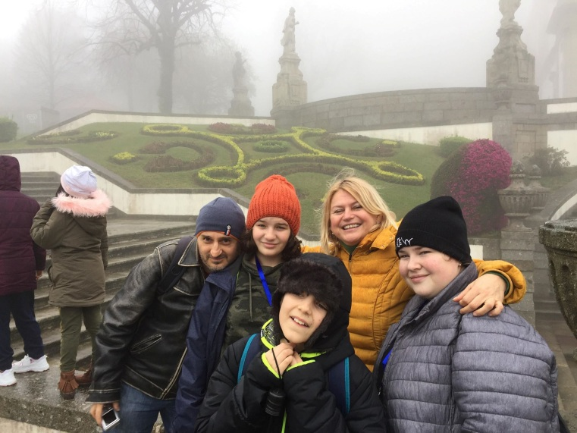
In the garden of the mountain

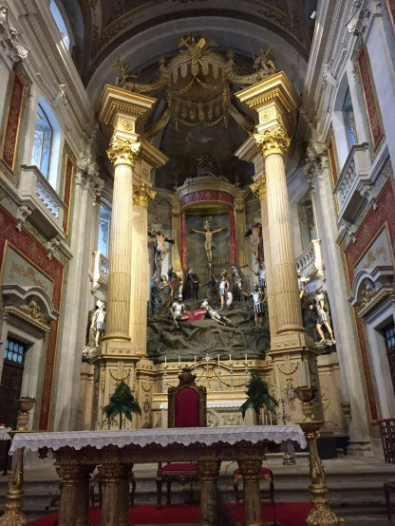
The church
This was the last programme today and we went home.

Day 4 (4 March Wednesday)

We went to see an Art and an ICT lesson, where we had to recognize and colour them.

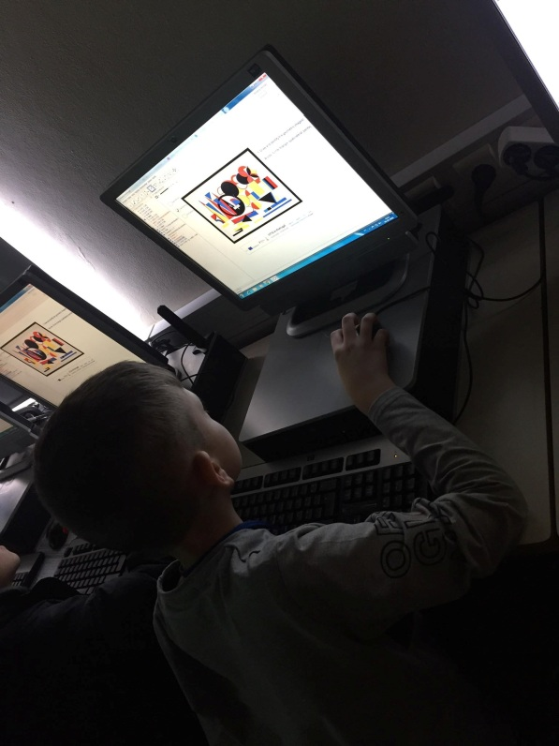

Then we went kayaking. I didn’t do it because I was afraid of falling into the water.

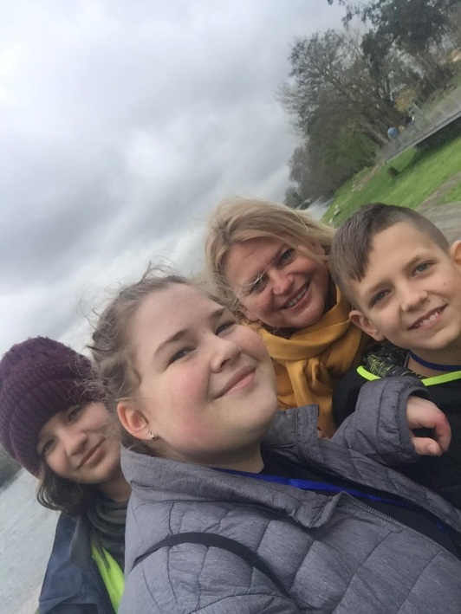

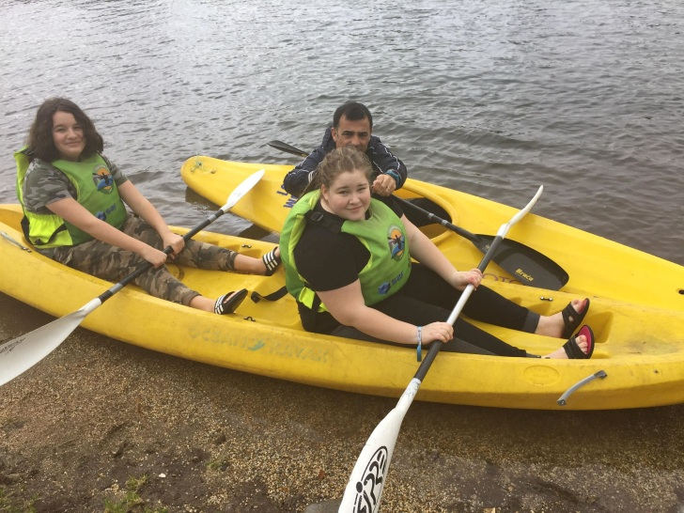
Kayaking

After kayaking we went home, and then the members of the group went to a bowling alley in Braga. We could have a laser fight the bowling hall in two groups.

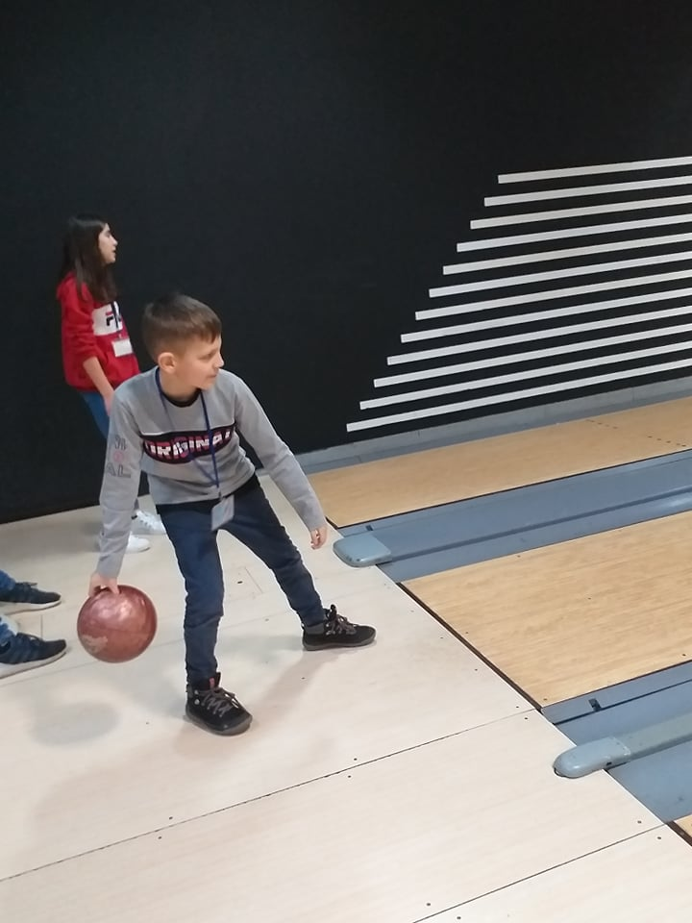
Bowling

After bowling We had dinner in Burger King and we went home from there at late night.

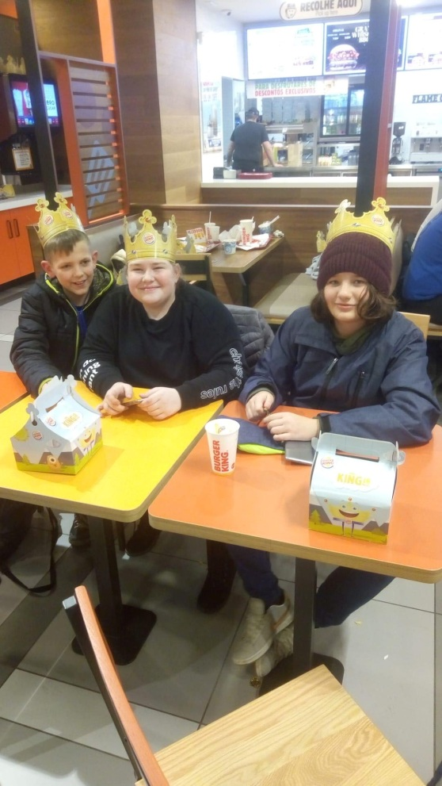
In the Burger King

Day 5 (5 March Thursday)

This was our day in Porto. When we arrived in Porto, we visited a school there. We were divided into two groups. We did some painting and we were shown around. We saw the Chemistry laboratory.

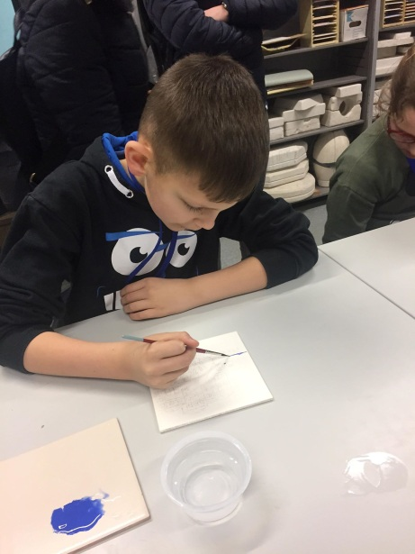
Painting
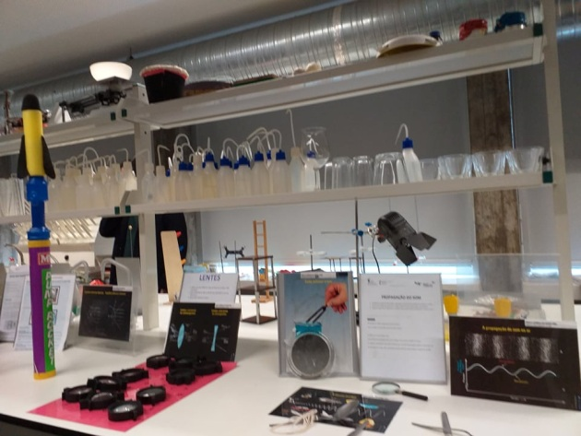
The lab

We went on a sightseeing tour and then to a beach.

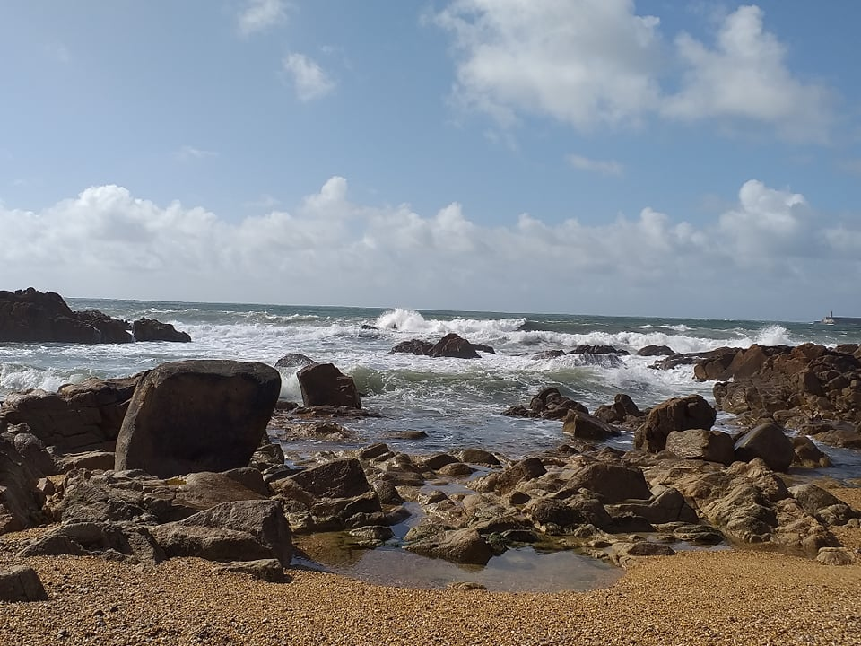

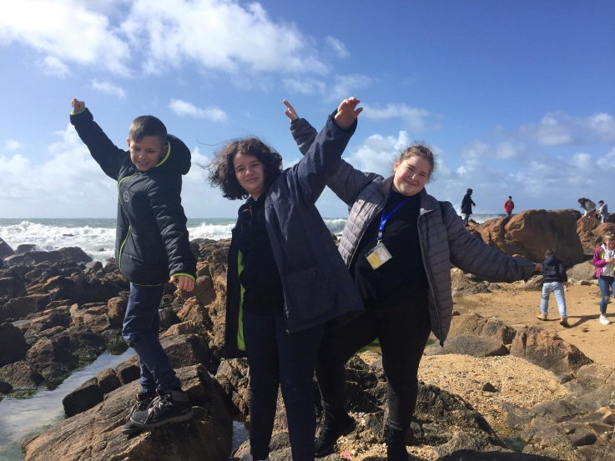

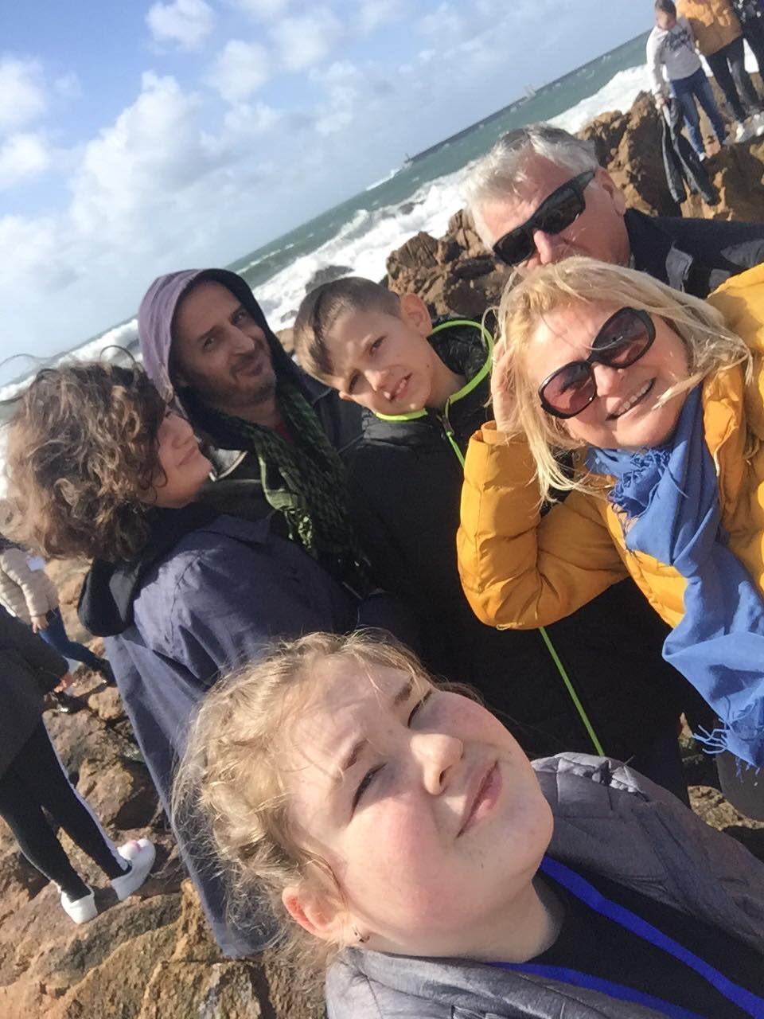

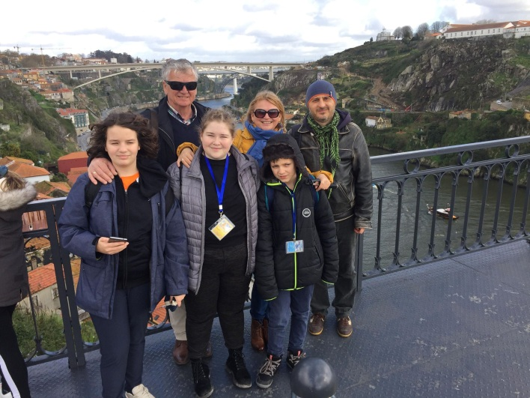

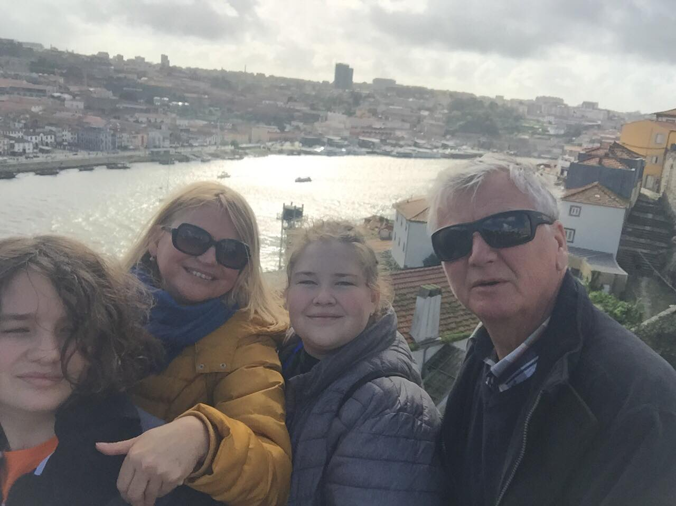
Day 6 (03.06. péntek)

We started our day in the school in Vila Verde. We spent the morning there, and after llunch we travelled to Braga. We saw a music shaw performed by the host children and we could try just dance too. There was a farewell party and all the participaing teachers, pupils and parents were there, After the party we went to see a football match. After the match we had dinner in a fast food restaurant and then we went home.

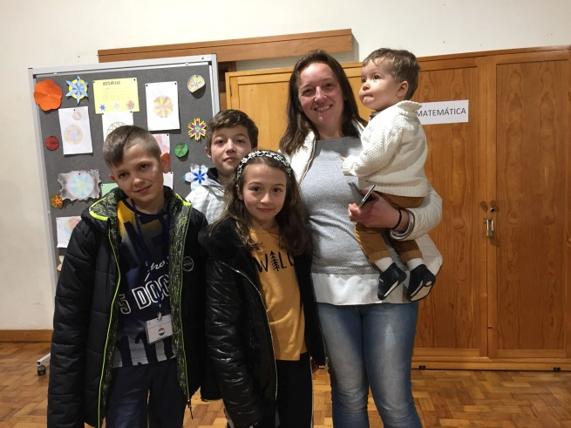
Me with my host family at the farewell party

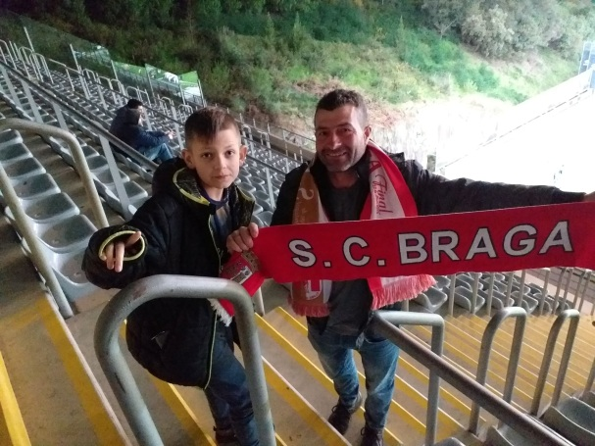
Me and Manuel (host father)

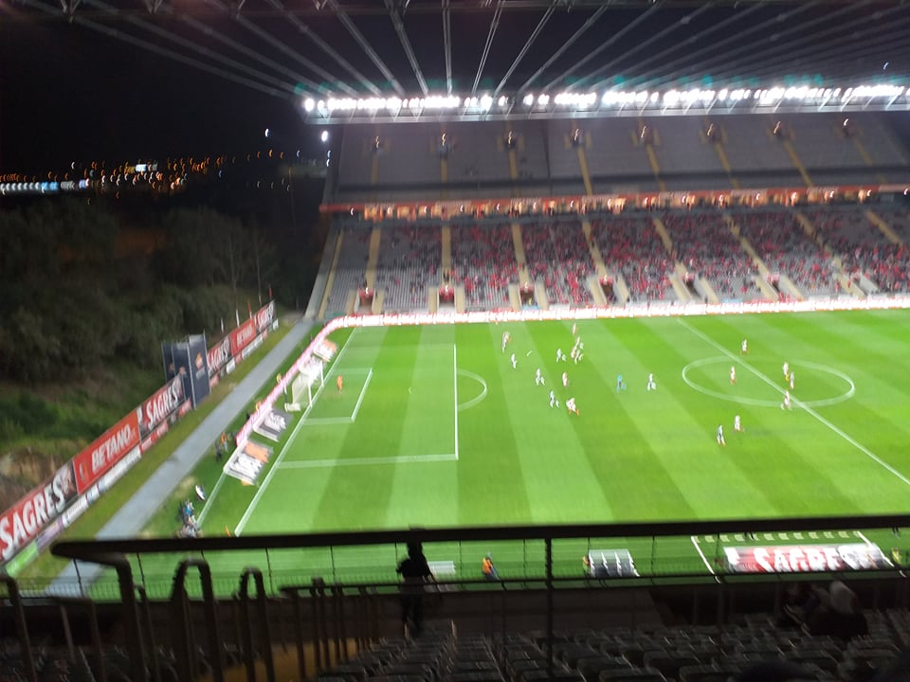
The match

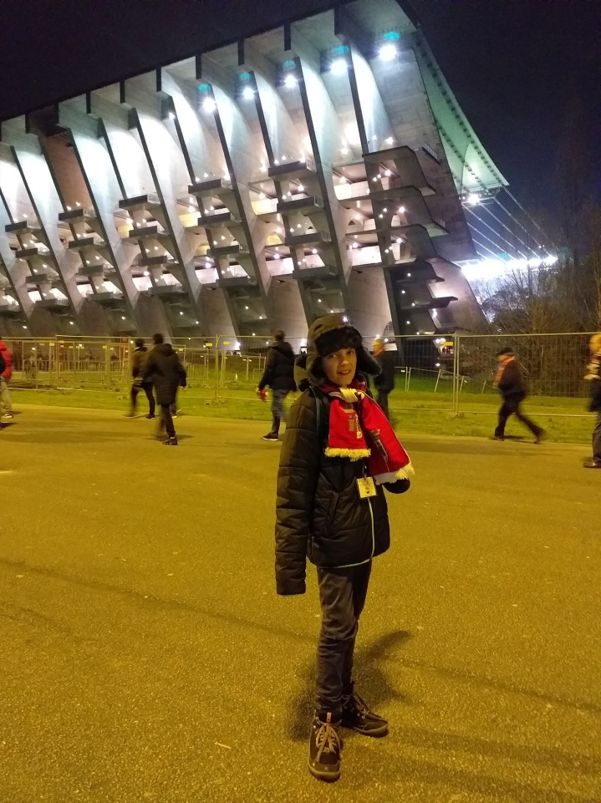

Day 7 (7 March Saturday)

This was our last day. We spent the day in Braga and we were taken to Porto airport. We ate ice-cream, we saw the famous sights of Braga and we went shopping to a flea market. Our plane took off in the evening and we arrived in Szeghalom early in the morning still full of experiences.

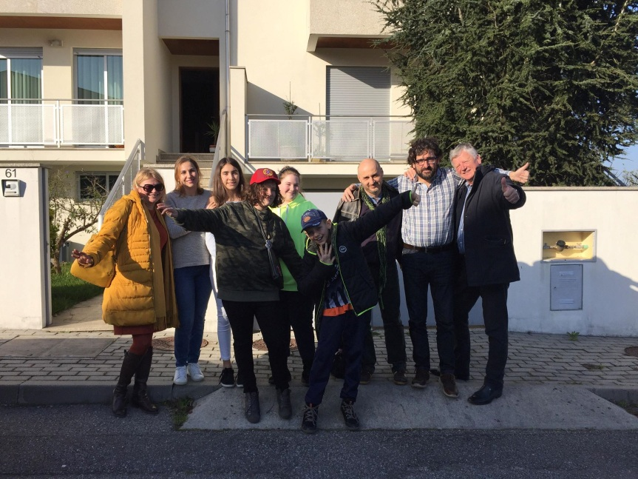
Farewell to Paolo and his family

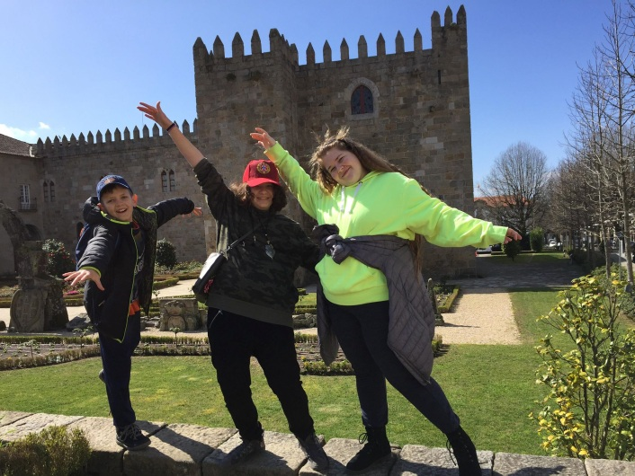

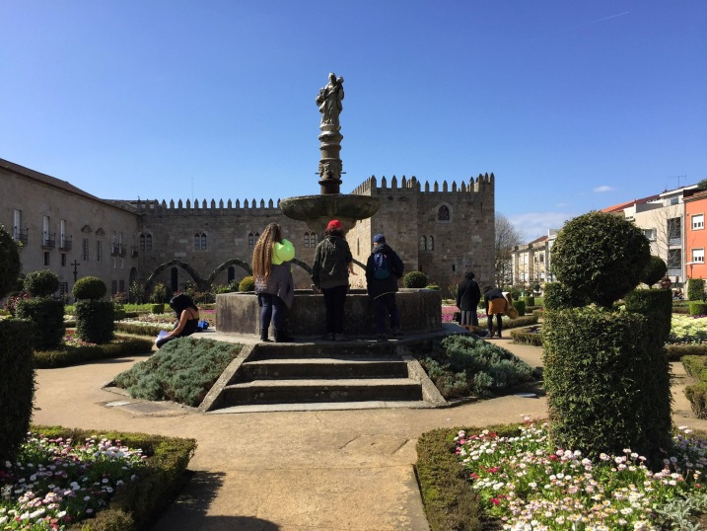

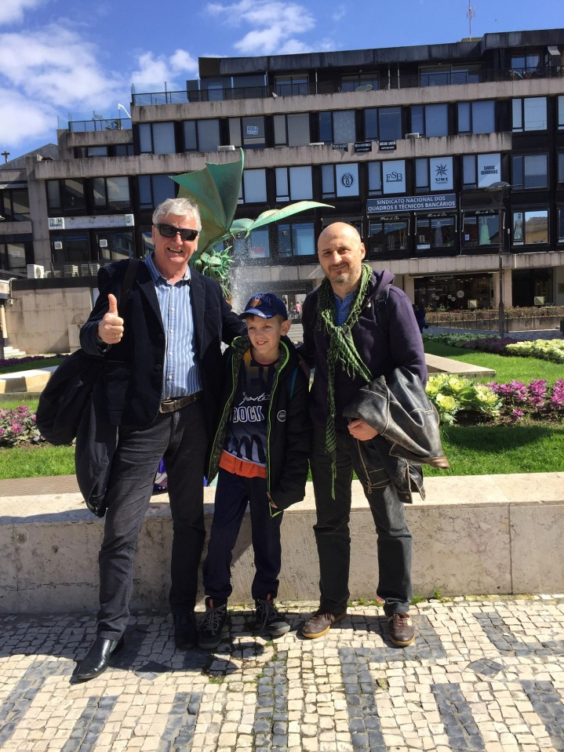
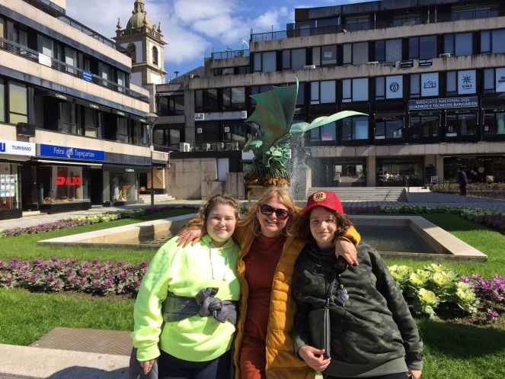

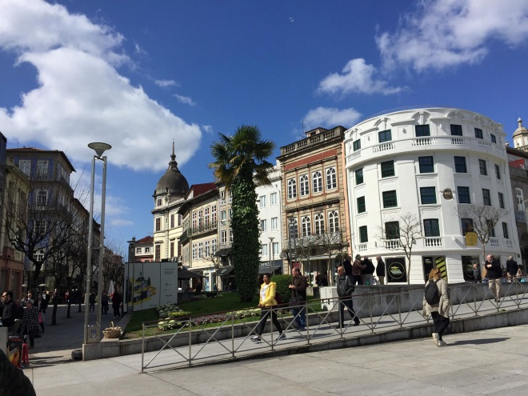

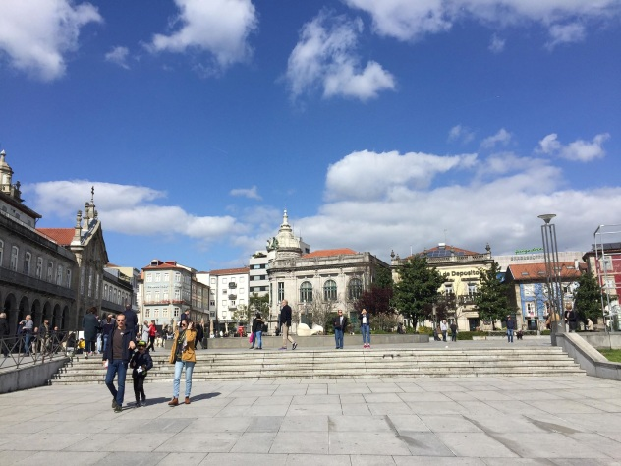

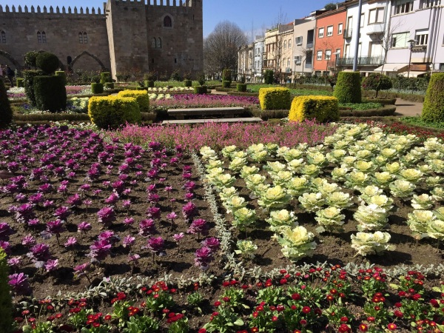

How did I like Portugal? It was fantastic?

