Bom Jesus Lift |  |  | LTTA in Portugal  02/03/20 – 06/03/20
The Bom Jesus lift works on a ramp, consisting of two independent cabins, connected by a funicular system with a water counterweight. Each cabin has a tank, which is filled with water on the upper level, and emptied on the lower level. The difference in weights allows its displacement. The amount of water is calculated according to the number of passengers in the cabins, for each trip.  It was built on the initiative of a Braga player at the end of the XIX century in order to replace a vehicle system on horse-drawn rails.  The project was created by the Swiss engineer who sent all the necessary information for the execution of the project and the installation of the equipment. The work began in March 1880 with the technical collaboration of a Portuguese engineer. The inauguration took place on 25th March 1882. |  | 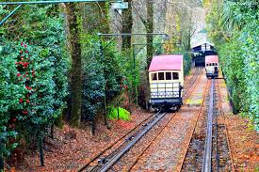  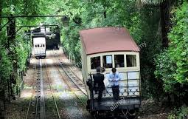  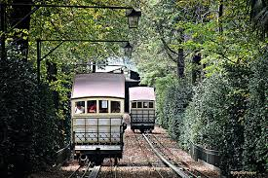
MATH (Math, Art and Technology in Harmony)
Project
Agrupamento de Escolas de Moure e Ribeira do Neiva

